The 29th International Youth Forum (IYF)

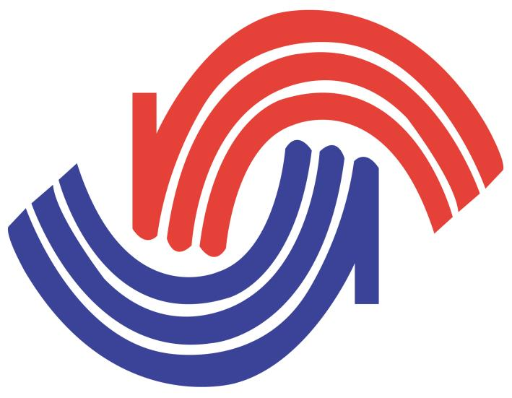

Request for Cooperation

May 2018

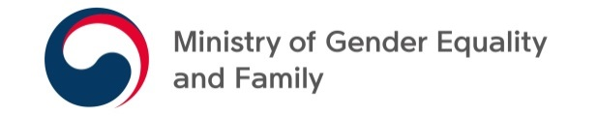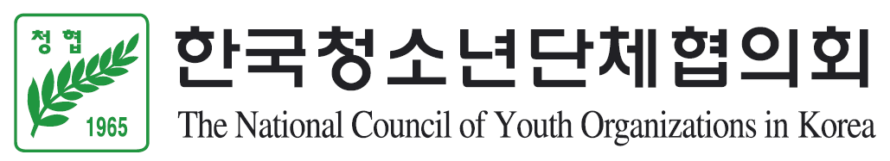

Recommendation and Selection of Participants
A. Qualifications
Youth aged between 18 and 26 years old
Must have an ability to communicate in English
A youth who is interested in this year’s theme (the 4th Industrial Revolution)
Must get recommendation letter (free form) from a principal, professors or heads of the companies and Homecoming Oath (Attachment 4)

B. Number of Recommended Participants:
Recommend 2 Persons from each country (1 Person for reserve)

C. Documents to submit
A list of participants (Attachment 1)
Application form and an English Essay (Attachment 2 / Attach the photo of participant)
Copies of passports (PDF)
Contact information of a person in charge (Attachment 3)
Submission method: compress files mentioned above and send to yul0918@koreayouth.net via email
Due date: June 11 (Mon), 2018

D. Request for Contact Information
Organizer: The National Council of Youth Organizations in Korea (NCYOK)
- The person in charge: Kyungyoul Lee (Officer)
- Phone: +82-2-2667-0875 - Fax: +82-2-2667-0479
- Email: yul0918@koreayouth.net - Website: www.ncyok.or.kr

