The 29th International Youth Forum (IYF)

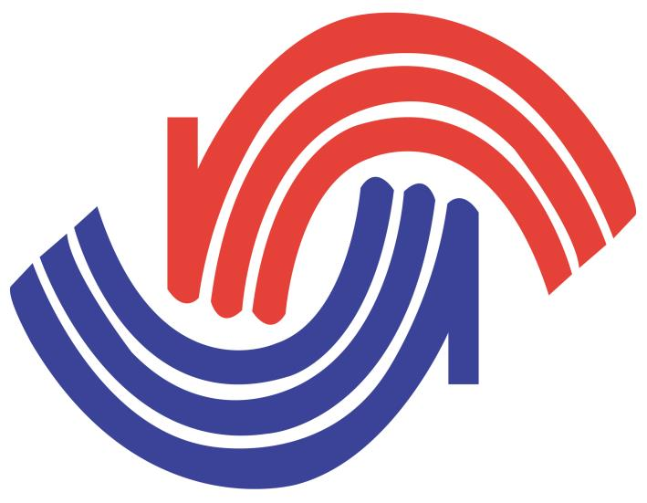

Program Briefing Paper

May 2018

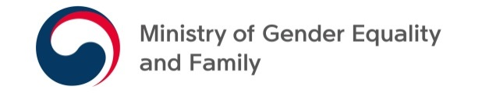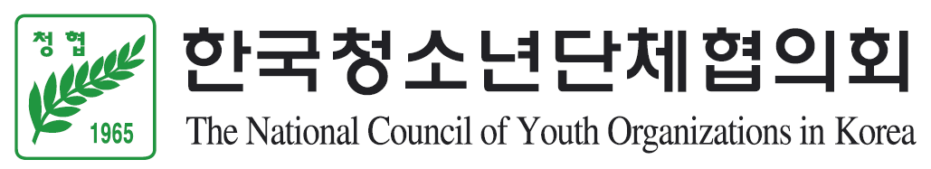

Call for Participants
The 29th International Youth Forum (IYF)

1. Objectives
- To increase youth’s understanding of global issues, offering an opportunity to tackle them and to find alternative ways or solutions.

- To improve cooperation and enhance mutual understanding among youths across cultures and nationalities.

- To spread goodwill around the world and to build interactive global citizenship through networking among youths.

2. Date and Venue
A. Date: 17 th ~ 23rd August, 2018

B. Venue: Seoul and Goyang City, Republic of Korea.

3. Theme: The 4th Industrial Revolution with Youth: Life in the Future
* 3 main topics and Sub-categories:
A. The Identity of the 4th Industrial Revolution: Changing Society
- Sub-category 1. Big Data and A.I.
- Sub-category 2. Two Sides of Personal Information Protection
- Sub-category 3. Imaginable Future of Urban Regeneration

B. The Change of Jobs Caused by the 4th Industrial Revolution: New Paradigms of
Career
- Sub-category 1. Disappearing Jobs
- Sub-category 2. Collaboration with A.I.
- Sub-category 3. Differentiated Capabilities for Human Being

C. The Role of Youth in Preparation for the 4th Industrial Revolution: Youth Policy
- Sub-category 1. Future Society that Youths will Create
- Sub-category 2. Solidarity and Cooperation among Youth around the World
- Sub-category 3. Solidarity and Cooperation around the World

※ Note
- All participants will be assigned to smaller working groups under the each sub-category
- All participants should indicate which sub-category you want to discuss in the application form
【The Background of Theme of the Forum】
We stand on the brink of a technological revolution that will fundamentally alter the way we live, work, and relate to one another. In its scale, scope, and complexity, the transformation will be unlike anything humankind has experienced before.

We do not yet know just how it will unfold, but one thing is clear: the response to it must be integrated and comprehensive, involving all stakeholders of the global polity, from the public and private sectors to academia and civil society.

Facing the new era, this year’s forum will offer a special opportunity to the participants from all around the world to share their ideas on 3 main topics for the 4th Industrial Revolution.

The youths who will lead the future society, will create results on how to make a successful era of the 4th Industrial Revolution through interactive and participative approach.

4. Organizers
A. Host: The Ministry of Gender Equality and Family, the Republic of Korea (MOGEF)

B. Organizers: The National Council of Youth Organizations in Korea (NCYOK)
Myongji University Industry and Academia Cooperation Foundation (MUIACF)

C. Sponsor: World Assembly of Youth (WAY), Asian Youth Council (AYC)

5. Participants
A. Overseas participants: 155 delegates

B. Korean participants: 30 delegates

6. Qualifications for Participation
A. Youths between the ages of 18 and 26 who have a strong interest in the topics

B. Youths who have a good command of English (official language)

7. Financial Aid for Foreign Participants * provided on the last day of forum
A. 600,000KRW (about 560USD) grant will be provided for travel cost (airfare) to the participants
from Africa, Oceania, Europe, and American regions.

B. 300,000KRW (about 280USD) grant will be provided for travel cost (airfare) to the participants
from Asian countries.
※ Note: The following applicants will be first considered
- who submit a good essay on the theme and topics
- who are studying the fields related to the theme and topics
- who are engaged in the fields related to the theme and topics
- who submit a recommendation letter from school or workplace

C. Host country will cover the expenses of accommodation, meals, and local transportation during
the forum.

8. Application and Required Documents
A. Application closing date is June 11 (Mon), 2018 (Korea Time)

B. Applicants need to submit:
1) A completed application
2) An English essay on the 4th Industrial Revolution
: A4, 1~2 pages, font 12, Times New Roman, single-spaced, including Title
3) Copy of passport (PDF)
4) Recommendation letter from school or workplace

C. Way of Selection: Recruitment and selection will be done based on selection criteria through
department or institution of each country’s government

9. Contact Information
* Kyungyoul Lee (Mr.)
- Program Officer / External Cooperation Team of NCYOK
- Tel: 82-2-2667-0875~6
- Fax: 82-2-2667-0479
- E-mail: yul0918@kordeayouth.net

10. Pictorial Record of the Forum
http://www.koreayouth.net/bbs/board.php?bo_table=06_7&wr_id=460

http://ncyok.or.kr/bbs/board.php?bo_table=eng_04&wr_id=26&page=0&sca=&sfl=&stx=&sst=&sod=&spt=0&page=0

11. Program Schedule

August 2018 | Activities | Remarks
17th  (Fri) | - Arrival / Registration  - Opening Ceremony / Welcome Dinner  * Hosted by Hon. Minter of Gender Equality and  Family, Republic of Korea  - Orientation  - Informal Meeting | ※ Accommodation  - Grand Hilton Seoul (https://www.grandhiltonseoul.com/)
18th  (Sat) | - Move to Goyang City (Tongyang Creativity Center)  - Election for Each Discussion Group Leader  - Special Lectures  - Discussion Time  - Informal Meeting | ※ Accommodation  - Tongyang Creativity Center  (http://www.tycc.co.kr/)
19th  (Sun) | - Discussion Time  - Informal Meeting
20th  (Mon) | - Compiling the Results of Discussion  - Experience Activity of the 4th Industrial Revolution  - Informal Meeting
21st (Tue) | - Experience Activity of the 4th Industrial Revolution  - Experience Activity at Korean Youth Centers  - Namsan Tower Tour & Korean Traditional  Village Tour
22nd (Wed) | - Korean Culture Experience  - Closing Ceremony and Farewell Dinner  * Hosted by Hon. President of NCYOK
23rd (Thu) | - Departure
- An Informal Meeting is not highly structured and doesn’t have a specific length, scope or other rigid component. At the Informal meetings, participants can freely exchange their opinions on any topics they want to discuss with other participants.
- The above schedules are subject to change

